Application form
for membership of the Board of
Warwickshire Rural Housing Association

Please return to:

Richard Mugglestone

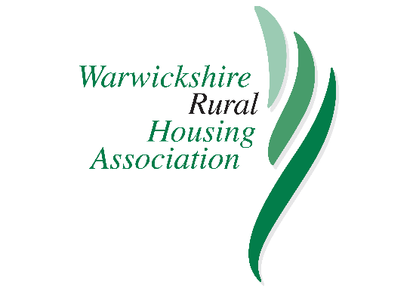
Email: richard.mugglestone@midlandsrural.org.uk

Post: Company Secretary
c/o Warwickshire Rural HA
Memorial House
Stenson Road
Coalville
Leicestershire LE67 4JP

Telephone: 0300 1234 009

PRIVATE AND CONFIDENTIAL

Title: |  | First name(s):
Surname:

Home address:  Postcode: |  | Contact numbers:  Home:  Work:  Mobile:  Email:
How did you hear about the opportunity to become a member of the WRHA Board?:

Work history:

Current and past positions of responsibility in public, private or voluntary sector organisations

Reasons for applying for WRHA Board membership:

(Please indicate what qualities and skills you feel would be relevant)

Do you have any personal or business relationships with any person or organisation, which may lead to a potential conflict of interest? (If YES, please provide details)

Special Note: In accordance with Homes England / Regulator of Social Housing requirements, Associations are unable to award work to the companies or firms of Board members or their close relatives where they have managerial control of those firms.
References

Please give the names, positions, organisations, address and email details, and telephone contact numbers of two referees:

1. Address  ……………………………………............  ……………………………………............  ……………………………………............  Email  ……………………………………............  Telephone number:  ……………………………………............ |  |  | Please indicate whether referees can be approached without your prior permission.  YES / NO (delete as appropriate)
2. Address  ……………………………………............  ……………………………………............  ……………………………………............  Email  ……………………………………............  Telephone number:  ……………………………………............ |  |  | Please indicate whether referees can be approached without your prior permission.  YES / NO (delete as appropriate)
Signature: ………………………………… |  |  | Date: ………………………………..

Equal Opportunities
DIVERSITY MONITORING FORM

The Association wishes to ensure that the composition of the Board of Management reflects the communities that it serves.

In order to meet this commitment, we need to ensure that monitoring arrangements are in place and kept up to date. The completion of this form will help us to do this. Thank you.

Do you consider yourself to have a disability? YES NO

If YES, please state the nature of your disability: ……………………………….

………………………………………………………………………………………………..

Are there any adjustments that could be made to enable you to carry out your duties as a Board or Committee Member more effectively? If YES, please provide details:

………………………………………………………………………………………………..

………………………………………………………………………………………………..

Ethnic or cultural origin

I would describe my ethnic origin as:

Asian/Asian British: Bangladeshi Chinese

Asian/Asian British: Indian Mixed: White and Black African

Asian/Asian British: Other Mixed: White and Black Caribbean

Asian/Asian British: Pakistani Mixed: Other

Black/Black British: African White: British

Black/Black British: Caribbean White: Irish

Black/African/Caribbean White: Other

Black/Black British: Other Other (Please specify):

